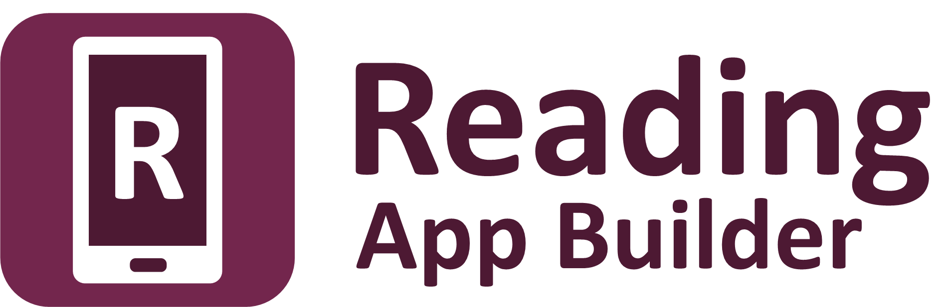

Running Workshops

Tips on running App Builder training workshops



Reading App Builder: Running Workshops

© 2017, SIL International

Last updated: 4 December 2017

You are free to print this manual for personal use and for training workshops.

The latest version is available at

<http://software.sil.org/readingappbuilder/resources/>

and on the Help menu of Reading App Builder.

**Contents**

1. Introduction 4

2. Before the workshop 4

2.1. Understand your participants 4

2.2. Prepare the course content 4

2.3. Prepare folders of files 5

2.4. Equipment needs 7

3. During the workshop 8

3.1. Installation tips 8

3.2. Building app tips 8

3.3. Using Android emulators 9

3.4. Tips for celebrating 9

# Introduction

This document outlines some tips and tricks you may find useful if you are running a training workshop for Reading App Builder.

# Before the workshop

## Understand your participants

Find out about each of the participants before they come:

* their interest in building apps;
* their desired outcomes as a result of the workshop;
* their computer skill level;
* what type of computer they will come with, i.e. Windows, Linux or Mac;
* what impact on their organization/community do they expect to see after they leave, etc.

## Prepare the course content

As you prepare the contents of the course, consider including sessions on the following:

* An introduction to smartphones and smartphone apps – and how they are being used in your part of the world. What changes are you seeing?
* How to install Reading App Builder and its components.
* How to create your first app from sample Word documents.
* How to synchronize text and audio, using Audacity and aeneas.
* How to create a picture story app, with background music and zoom/pan effects.
* How to create your first app from sample Bloom books.
* How to create a song book app.
* How to create an app with a contents menu.
* How to create an app with an expiry date.
* How to configure your app with colors, borders, icons, splash screen, etc.
* How to get the About Box information right: understanding copyright and licensing.
* How to check that an app is ready to publish (using the App Publishing Checklist).
* How to distribute your apps: Google Play, memory card, Bluetooth, Wifi sharing app (SHAREit, Xender), offline Wifi routers, etc.
* How to market your apps on social media, e.g. Facebook. How to do smartphone screen-recording so you can include short video clips of the app to use on your Facebook page.

Make sure each session has clear learning objectives with plenty of time for the participants to practice building apps.

## Prepare folders of files

Prepare folders of files to distribute to the participants.

Include the following items:

* Instruction manuals:
  + Download each of the manuals in PDF format here: <http://software.sil.org/readingappbuilder/resources/>
* Installation files:
  + Reading App Builder setup program:

**Reading-App-Builder-4.1-Setup.exe**, or a later version.

(download the latest installer from the [Reading App Builder website](http://software.sil.org/readingappbuilder/download/)).

* + JDK installer: include both 64-bit and 32-bit versions

**jdk-8u151-windows-i586.exe** - for 32-bit Windows

**jdk-8u151-windows-x64.exe** – for 64-bit Windows

Download the latest files from the [JDK 8 Downloads website](http://www.oracle.com/technetwork/java/javase/downloads/jdk8-downloads-2133151.html).

* + Android SDK:

Instead of asking the workshop participants to install the Android SDK from the command line tools setup program and then download the additional components from the internet, it is easier to package all of your Android SDK files as a single zip file.

To do this, assuming you have already installed the Android SDK yourself, find the Android SDK folder on your computer with all of the files already downloaded. Zip the contents of the folder including all of its sub-folders.

The participants will need to unzip this file onto their hard disks, e.g. to c:\sdk. There is no setup program to run, no need to use SDK Manager and no need to access the internet.

For more details, please see the Android SDK section of the *Installation Instructions* manual.

* + aeneas tools setup program:

aeneas-windows-setup-1.7.2.exe

(download the latest installer from the [Reading App Builder website](http://software.sil.org/readingappbuilder/download/)).

* + Gradle cache folder:

Reading App Builder normally needs internet access the first time you build an app. It will download a set of libraries used by the Gradle compiler. If you want to enable workshop participants to build apps without needing internet access, it is possible to copy the Gradle cache files to a folder on their computer and then tell RAB where there are to be found.

This will only work, however, if the absolute path to the files is exactly the same on the computer from which the files are taken as on the participant’s computer, e.g. “C:\gradle” on computer A and “C:\gradle” on computer B. It will not work if you have “C:\Users\John\.gradle” or computer A and “C:\Users\Jenny\.gradle” on computer B (which is the default Gradle cache folder).

So, on computer A, to get the cache files to distribute:

1. Go to Tools > Settings > Build Settings > Gradle Cache Folder.
2. Enter “C:\gradle” and OK.
3. Build an app. The Gradle cache files will be downloaded to C:\gradle.

Then, on computer B:

1. Copy the C:\gradle folder from computer A to C:\gradle.
2. Go to Tools > Settings > Build Settings > Gradle Cache Folder.
3. Enter “C:\gradle” and OK.

* Installation files for Mac:
  + If some of your participants will come with Apple Mac computers, include the relevant Reading App Builder installation files for Mac. Refer to the document *Installing and Building Apps on a Mac* for more details.
* Sample files:
  + Sample story text, pictures and audio files
  + Sample songs in text and audio format
* Extra software:
  + Bloom - <http://bloomlibrary.org>
  + Notepad++ - <https://notepad-plus-plus.org>
  + Audacity - <http://www.audacityteam.org>
  + 7zip - <http://www.7-zip.org>
* Other App Builders:
  + Dictionary App Builder:

(download the latest installer from the [Dictionary App Builder website](http://software.sil.org/dictionaryappbuilder/download/)).

* + Scripture App Builder:

(download the latest installer from the [Scripture App Builder website](http://software.sil.org/scriptureappbuilder/download/)).

## Equipment needs

You will need:

* A **data projector** and **screen**.
* **Internet access**: required for the build of the first app (unless you copy the Gradle cache folder between computers).
* A **smartphone with a data package**: this can be very useful in case it is needed as an emergency hotspot (such as to install Java for a computer that doesn’t have it already). Some workshop locations struggle if a room of people are trying to connect to the internet at once.
* **Spare USB cables and adapters** for those participants who do not come with them.
* A **means of distributing files** to the participants: [BibleBox](http://www.biblebox.org), [LibraryBox](http://librarybox.us/), [LightStream](http://www.renewoutreach.com/lightstreams/), USB memory sticks, etc.
* A **Google Chomecast** device to display a smartphone screen on the data projector. This will require an HDMI port on the projector.

**Equipment for participants**

Ask participants to bring the following equipment with them:

* a laptop computer;
* an Android smartphone or tablet;
* a USB cable to connect their phone to their computer;
* microSD card and microSD card adapter;
* a headset with microphone for recording.

The list of installation files in the section above assumes participants will come with Windows laptops. If any have Linux or Mac computers, you will need to research if and how you can assist them in installing RAB.

# During the workshop

## Installation tips

* Explain clearly how to install the three main components: (i) Reading App Builder, (ii) JDK, and (iii) Android SDK. For (i) and (ii), there are setup programs to run. For (iii), it is simply a matter of unzipping a file to a folder.
* Provide printed installation instructions and encourage the participants to check each step as they complete it. They could work in pairs during this process.
* Distribute software components via BibleBox, Pirate Box, LightStream, Windows File-sharing, etc.
* If using a BibleBox, Pirate Box, or LightStream for file-sharing, spend a few minutes to explain the interface so the concept is not only presented, but demonstrated and used.
* It can be helpful for participants to reboot their computers immediately after installing Reading App Builder.
* Participants could install the components either before they come or in the evening/free time.

## Building app tips

* Create an environment where participants are free to ask questions and are able to get help from the facilitator and participants. Consider creating partner pairs or small groups. Use open questions like, “What are your questions?” instead of “Does anyone have a question?”
* Manage time and skill development by observing participants work. Expect to adjust the schedule. Ask for feedback each day.
* Ask participants read the information (perhaps out loud) in each window of the wizard during the build process and check for understanding.
* Explain the package name choice clearly.
* Give guidance on copyright and licensing, including giving a sample license file in the official language of the country.
* Have participants observe each option, from the tree menu on the left and tabs on the right, and make any corrections if needed.
* Have participants click **Tools** ⮚ **Settings** and look at each tab, making corrections if needed.
* Demonstrate how to share the Gradle cache between computers to avoid the need for an internet connection for the first-time they compile an app. See the instructions above about the Gradle Cache folder in ‘Prepare folders of files’.

## Using Android emulators

You may want to use an Android emulator to test apps on the computer, such as:

* ARC Welder plug-in for Chrome (English interface only),
* Genymotion (www.genymotion.com), or
* Andy (www.andyroid.net).

It is helpful if participants can download the emulator prior to the workshop. Otherwise, there needs to be a good internet connection on location.

Remember, however, that an emulator is not a substitute for testing the apps on physical smartphone devices.

## Tips for celebrating

* Encourage participants to build a sample app that meets a need of their community/organization and “show & tell” at a closing ceremony.
* Invite colleagues, community leaders and officials to your “show and tell” ceremony. Invite one of them to close the ceremony.
* Have each participant or pair demonstrate their app on the projector using an Android app emulator or a screen casting device such as Google Chromecast.
* Consider giving certificates of participation, if appropriate.
* Celebrate with food.